BIT4138: Advanced Cryptography Logbook

Name: Roman Nyaramba

Adm Number: BSCCS/2023/62156

Course: Computer Science

Unit Code: BIT4138

Lec Name: Mr Nyoro

Academic Year: 3.2

Table of Contents

Week 1: Introduction to Classical Cryptography.....3
Fig 1: Caesar Cipher Encryption and Decryption.....3
Fig 2: Vigenere Cipher Encryption and Decryption...3
Fig 3: Frequency Analysis of Ciphertext............3
Fig 4: Shannon Entropy Calculation.................3
Fig 5: Unicity Distance Demonstration..............3
Student Reflection.....................................3

Week 2: Stream Ciphers Randomness and Pseudorandomness...4
Fig 1: Linear Congruential Generator Output........4
Fig 2: One Time Pad Encryption and Decryption......4
Fig 3: LFSR Sequence Generation....................4
Fig 4: Keystream Generator Encryption..............4
Fig 5: Pseudorandom vs True Random Comparison......4
Student Reflection.....................................4

Week 3: Stream Ciphers Statistical Testing of PRNGs......5
Fig 1: Monobit Frequency Test......................5
Fig 2: Runs Test...................................5
Fig 3: Autocorrelation Test........................5
Fig 4: Linear Complexity Profile...................5
Fig 5: Chi Square Uniformity Test..................5
Student Reflection.....................................5

Week 4: Stream Ciphers Cryptanalysis.......................6
Fig 1: Berlekamp Massey Algorithm Demonstration....6
Fig 2: Correlation Attack Simulation...............6
Fig 3: Algebraic Attack Binary Equation Solving....6
Fig 4: Known Plaintext Attack on Stream Cipher.....6
Fig 5: Statistical Bias Detection in PRNG..........6
Student Reflection.....................................6

Week 5: Block Ciphers Feistel Networks and Confusion Diffusion...7
Fig 1: Feistel Cipher Encryption and Decryption....7
Fig 2: S Box Substitution Confusion................7
Fig 3: Permutation Diffusion.......................7
Fig 4: Full Substitution Permutation Network SPN...7
Fig 5: Avalanche Effect Demonstration..............7
Student Reflection.....................................7

Week 1: Introduction to Classical Cryptography

Title
Introduction to Classical Cryptography Information Theory and Cipher Security

Required Evidence
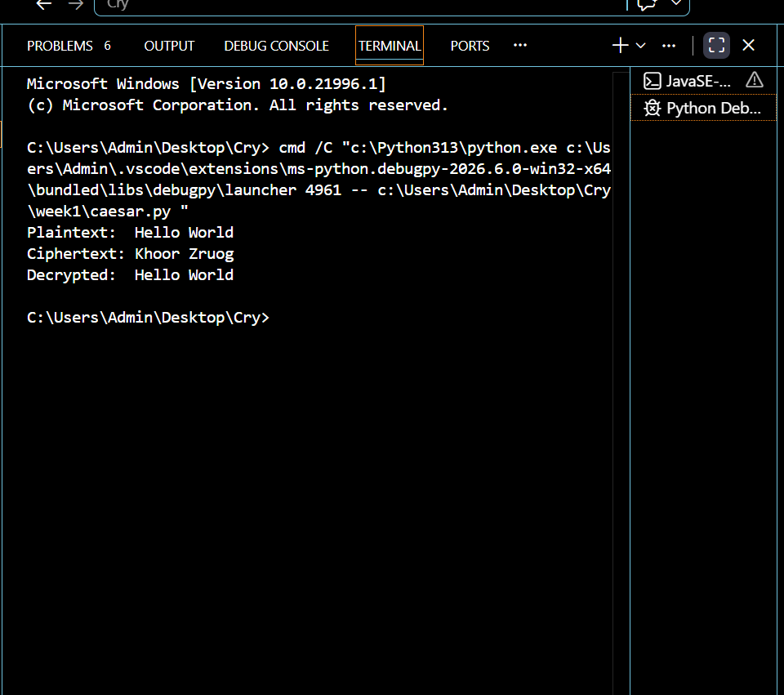
Fig 1: Caesar Cipher Encryption Example
Screenshot showing a plaintext message encrypted using a Caesar Cipher with a shift of 3 implemented in Python or demonstrated via an online cipher tool.

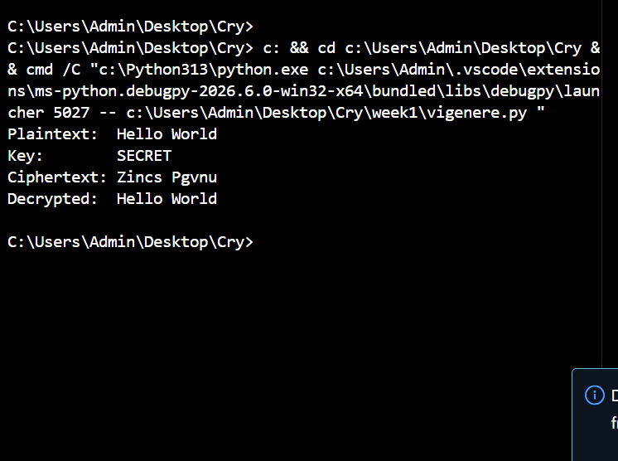
Fig 2: Vigenère Cipher Encryption
Screenshot showing encryption of a message using the Vigenère Cipher with a keyword highlighting how each letter shifts differently.
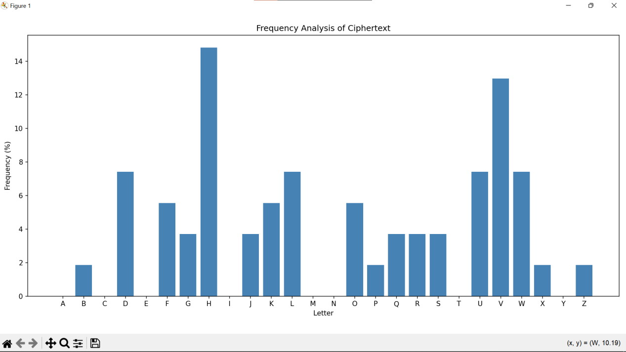
Fig 3: Frequency Analysis Chart
Screenshot of a frequency analysis graph applied to a ciphertext demonstrating how letter patterns expose weaknesses in substitution ciphers.
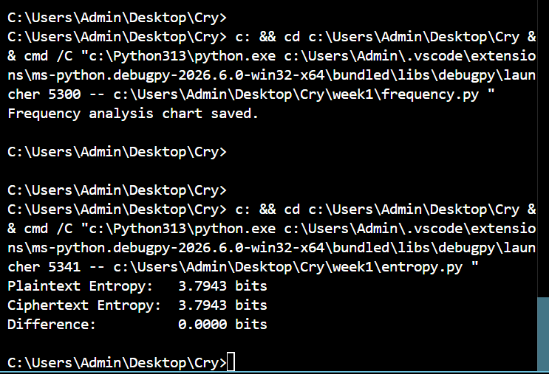
Fig 4: Entropy Calculation
Screenshot of a Python script computing Shannon entropy of a plaintext and its corresponding ciphertext to compare unpredictability.

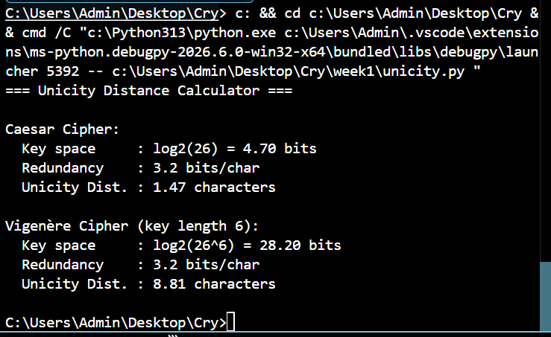
Fig 5: Unicity Distance Demonstration
Screenshot or written calculation showing the unicity distance of a sample cipher explaining the minimum ciphertext length required to uniquely determine the plaintext.

Student Reflection
This week introduced the foundations of cryptography through classical ciphers. The Caesar Cipher applies a fixed shift making it vulnerable to brute force across only 25 possible keys. The Vigenère Cipher improves security using a repeating keyword but remains susceptible to frequency analysis once the key length is determined using the Kasiski test. Fig 3 demonstrated how letter frequency patterns survive substitution exposing plaintext structure. Shannon entropy (Fig 4) confirmed that stronger ciphers produce output closer to maximum unpredictability. Unicity distance (Fig 5) showed that shorter ciphertexts carry insufficient information to uniquely determine the plaintext without redundancy

WEEK 2: Stream Ciphers Randomness & Pseudorandomness

Title
Randomness Pseudorandomness One Time Pad and Keystream Generators

Required Evidence
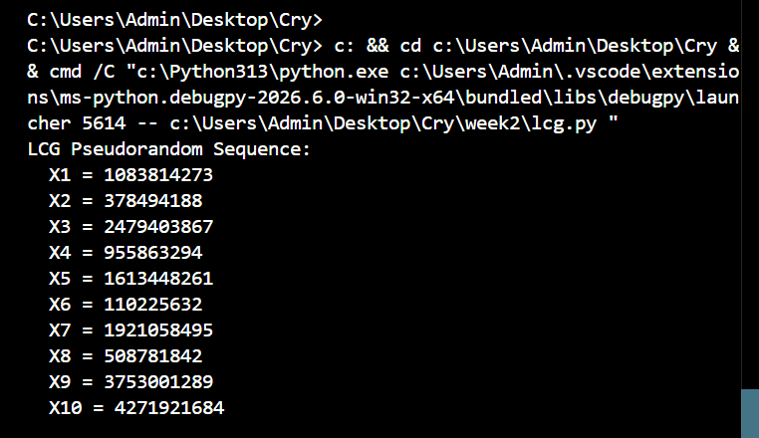
Fig 1: Linear Congruential Generator (LCG) Output
Screenshot showing a Python implementation of an LCG producing a pseudorandom sequence displaying generated values with the seed multiplier increment and modulus parameters.

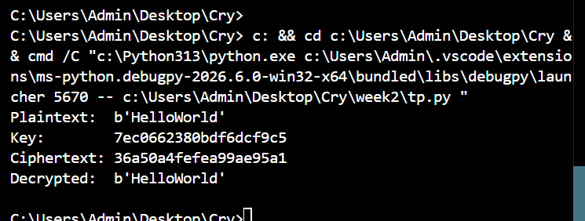
Fig 2: One Time Pad Encryption and Decryption
Screenshot showing a plaintext message encrypted using a randomly generated key of equal length via XOR operation and successfully decrypted back to the original message.

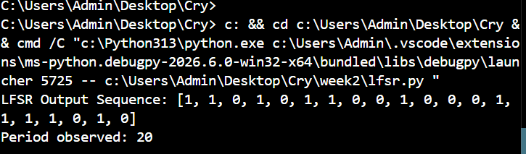
Fig 3: LFSR (Linear Feedback Shift Register) Sequence
Screenshot showing an LFSR implementation with a defined seed and tap positions generating a binary output sequence with the observed period displayed.

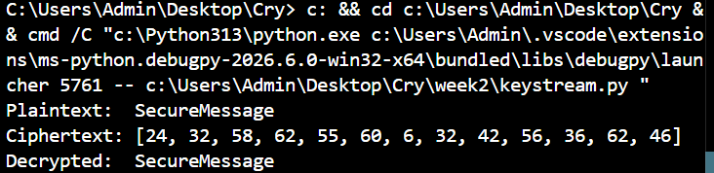
Fig 4: Keystream Generator Encryption
Screenshot showing a keystream-based encryption where plaintext is XORed with a repeating key to produce ciphertext and decrypted back successfully using the same keystream.

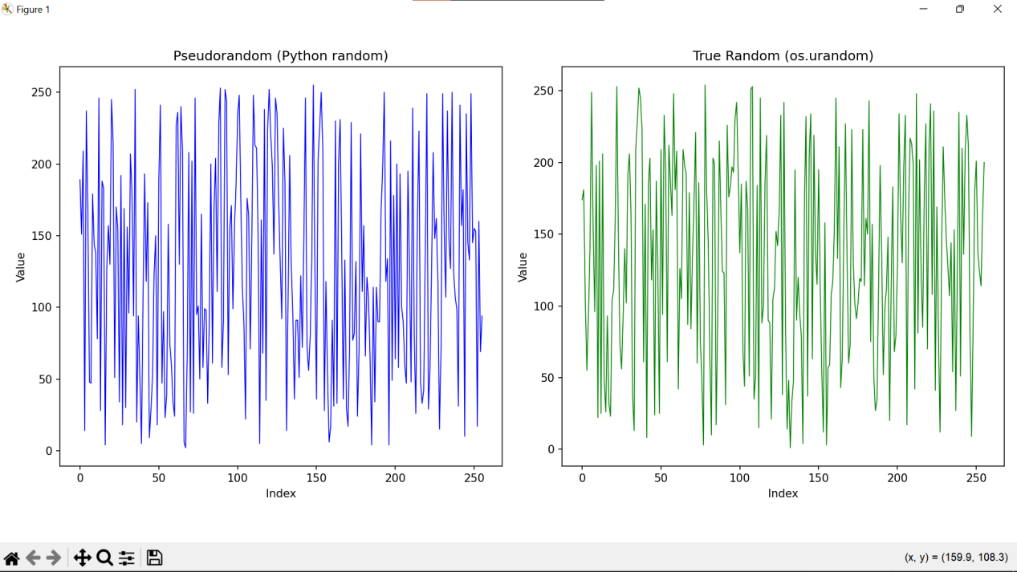
Fig 5: Pseudorandom vs True Random Comparison
Screenshot showing a matplotlib graph comparing the output distribution of Python's pseudorandom generator against os.urandom() visually demonstrating the difference between pseudorandomness and true randomness.

Student Reflection
This week explored the distinction between true randomness and pseudorandomness in stream cipher design. The LCG (Fig 1) demonstrated how deterministic mathematical formulas simulate randomness using a seed value. The One-Time Pad (Fig 2) confirmed that XOR encryption with a truly random key of equal length achieves perfect secrecy. The LFSR (Fig 3) showed how binary feedback sequences generate keystreams efficiently. Fig 4 demonstrated practical keystream encryption while Fig 5 visually confirmed that pseudorandom sequences closely approximate true randomness but remain deterministic and reproducible given the same seed a critical security consideration in stream cipher design.

WEEK 3: Stream Ciphers Statistical Testing of PRNGs

Title
Period Linear Complexity and Statistical Testing of Pseudorandom Sequences

Required Evidence

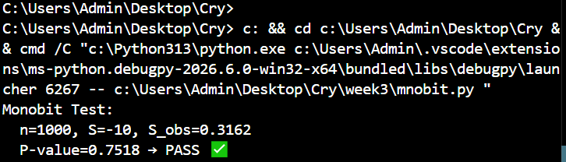
Fig 1: Monobit Frequency Test
Screenshot showing a Python implementation of the NIST monobit test applied to a generated binary sequence displaying the proportion of ones and zeros the p-value and a PASS/FAIL result.

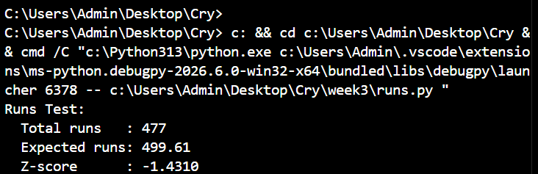
Fig 2: Runs Test
Screenshot showing the runs test applied to a pseudorandom binary sequence displaying the total number of runs detected expected runs Z-score and whether the sequence passes the randomness threshold.

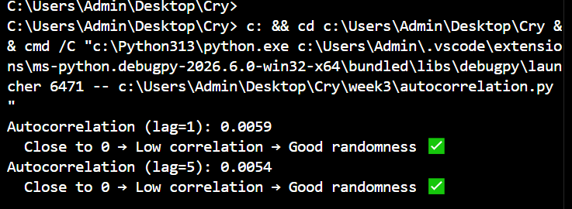
Fig 3: Autocorrelation Test
Screenshot showing autocorrelation computed at multiple lag values on a binary sequence demonstrating that values close to zero indicate low correlation and confirm good randomness properties.

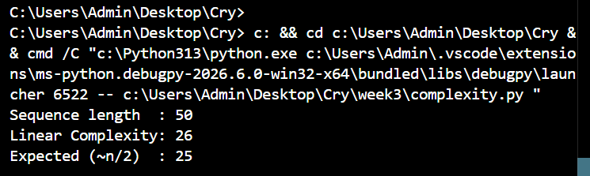
Fig 4: Linear Complexity Profile (Berlekamp-Massey)
Screenshot showing the Berlekamp-Massey algorithm computing the linear complexity of a binary sequence comparing the result against the expected value of approximately n/2 for a truly random sequence.

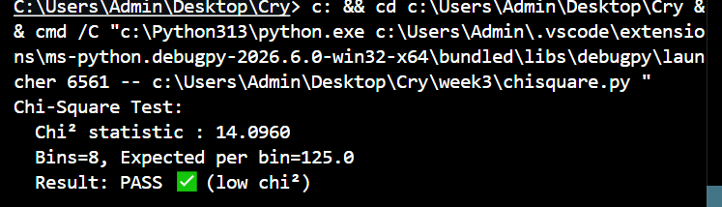
Fig 5: Chi-Square Uniformity Test
Screenshot showing a chi-square test applied to a pseudorandom sequence, displaying the chi-square statistic number of bins expected frequency per bin and a PASS/FAIL verdict indicating uniformity of distribution.

Student Reflection
This week focused on verifying the quality of pseudorandom sequences through statistical testing. The monobit test confirmed that ones and zeros appear with approximately equal frequency. The runs test verified independence between successive bits. Autocorrelation measured dependency between values at different lag positions values near zero confirmed low correlation. The Berlekamp-Massey algorithm computed linear complexity where a result close to n/2 indicates strong unpredictability. The chi-square test verified uniform distribution across output values. Together these tests validate that a PRNG is suitable for cryptographic use in stream ciphers.

WEEK 4: Stream Ciphers – Cryptanalysis

Title
Cryptanalysis of Stream Ciphers: Berlekamp-Massey Correlation and Algebraic Attacks

Required Evidence

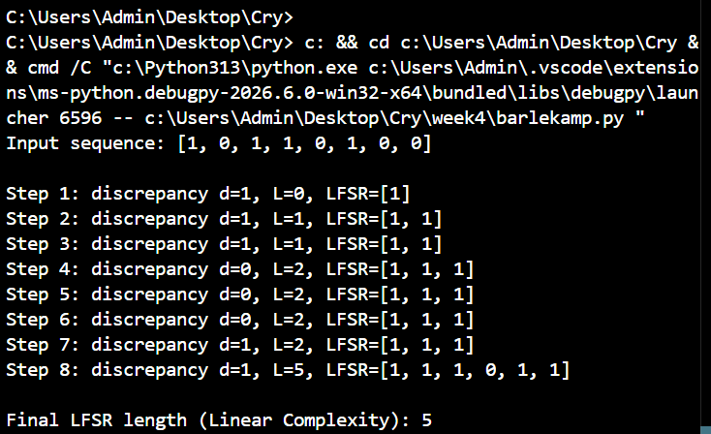
Fig 1: Berlekamp-Massey Algorithm Verbose Demonstration
Screenshot showing a step-by-step execution of the Berlekamp-Massey algorithm on a binary sequence displaying each step's discrepancy value current LFSR polynomial and the final computed linear complexity.

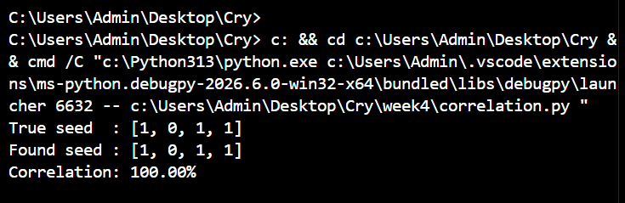
Fig 2: Correlation Attack Simulation
Screenshot showing a correlation attack on an LFSR-based stream cipher where all possible seeds are tested against an observed keystream and the correct seed is identified based on highest correlation score.

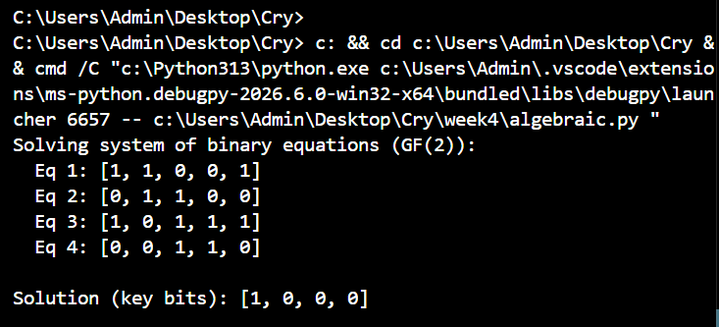
Fig 3: Algebraic Attack Binary Equation Solving
Screenshot showing a system of binary linear equations solved using Gaussian elimination over GF(2), recovering key bits from the algebraic representation of the cipher's output function.

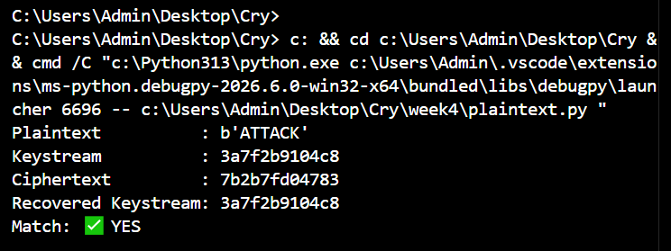
Fig 4: Known Plaintext Attack on Stream Cipher
Screenshot showing how a known plaintext attack recovers the keystream by XORing known plaintext with the corresponding ciphertext then using the recovered keystream to decrypt additional messages.

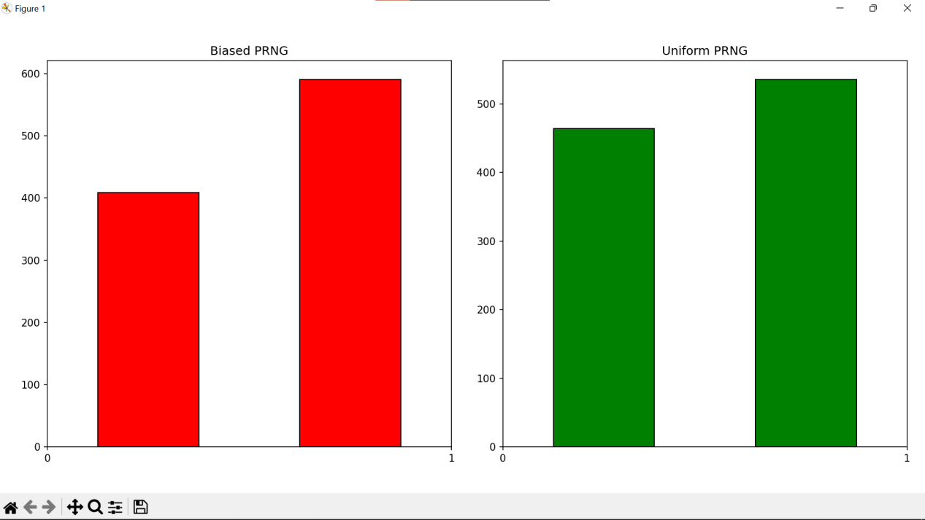
Fig 5: Statistical Bias Detection in PRNG
Screenshot showing a comparison between a biased PRNG (60% ones) and a uniform PRNG (50% ones) using histograms demonstrating how statistical bias in a keystream can expose a stream cipher to cryptanalysis.

Student Reflection
This week examined methods used to break stream ciphers. The Berlekamp-Massey algorithm
reconstructs the shortest LFSR capable of producing a given sequence exposing weak keystream generators. The correlation attack exploits statistical dependence between individual LFSR outputs and the combined keystream. Algebraic attacks model the cipher as a system of equations solvable over. The known plaintext attack demonstrated that XORing known plaintext with ciphertext directly recovers the keystream. confirmed that even slight statistical bias in keystream output is detectable and exploitable highlighting the need for cryptographically secure PRNGs.

WEEK 5: Block Ciphers Feistel Ciphers & Confusion/Diffusion

Title
Block Cipher Fundamentals: Feistel Networks Confusion Diffusion and the Avalanche Effect

Required Evidence

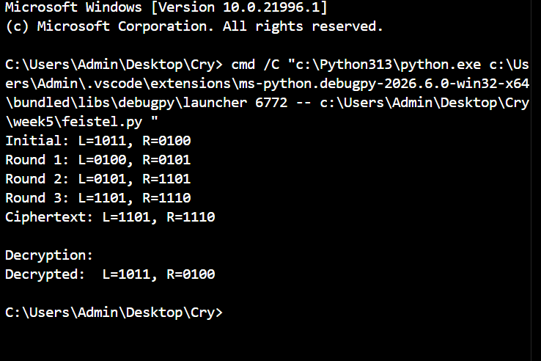
Fig 1: Feistel Cipher Encryption and Decryption
Screenshot showing a Feistel cipher encrypting an 8-bit plaintext through multiple rounds using round keys displaying the left and right halves at each round and successfully decrypting the ciphertext back to the original plaintext.

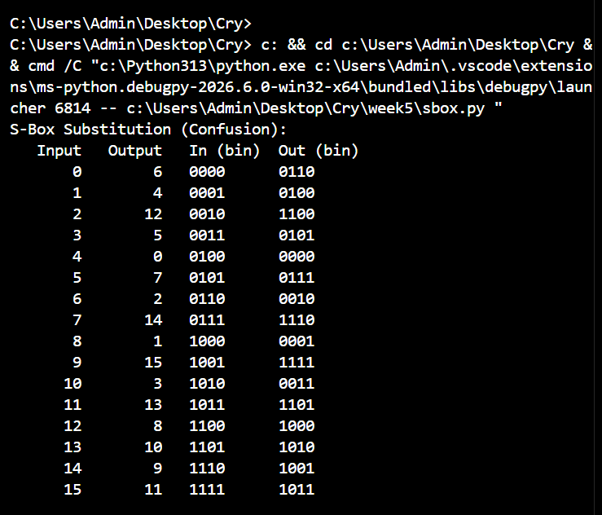
Fig 2: S-Box Substitution (Confusion)
Screenshot showing a 4-bit S-Box substitution table where each 4-bit input nibble maps to a non-linear output nibble demonstrating how confusion obscures the relationship between plaintext and ciphertext

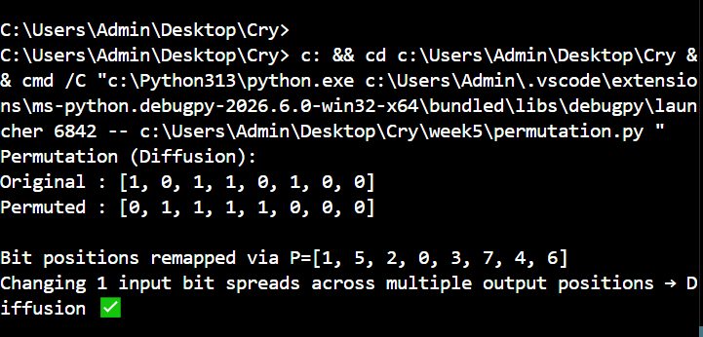
Fig 3: Permutation (Diffusion)
Screenshot showing a bit permutation function remapping the positions of bits in a block with the original and permuted bit strings displayed side by side demonstrating how a single bit change spreads across multiple output positions.

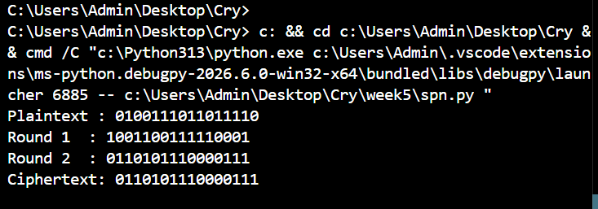
Fig 4: Full Substitution Permutation Network
Screenshot showing a complete SPN executing two rounds of key mixing S-box substitution and bit permutation on a 16-bit plaintext block displaying the intermediate state after each round through to the final ciphertext.

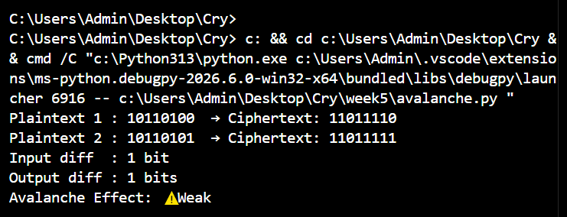
Fig 5: Avalanche Effect Demonstration
Screenshot showing two plaintexts differing by exactly one bit encrypted through the Feistel cipher with the output ciphertext bits compared to confirm that a single input bit change causes multiple output bit differences demonstrating the avalanche effect.

Student Reflection
This week introduced block cipher design principles through the Feistel network. Fig 1 demonstrated that Feistel ciphers achieve encryption and decryption using the same structure by simply reversing round keys a computationally elegant property. The S-Box (Fig 2) introduced confusion by creating a non-linear mapping between input and output nibbles making algebraic analysis difficult. Permutation (Fig 3) achieved diffusion by spreading bit influence across the entire block. Fig 4 combined both in a full SPN while Fig 5 confirmed the avalanche effect a single bit change in plaintext altered multiple ciphertext bits demonstrating strong diffusion essential in secure block cipher design.

